

**The Experiment Report of**

***Deep Learning***

**College: Software Engineering**

**Subject: Deep Learning**

**E-mail: nabeel10561@gmail.com**

**Tutor: Ming Kui tan**

**Date-submitted:2017.12.15**

**1. Topic:** Logistic Regression, Linear Classification and stochastic gradient descent

**2. Time:** 14-12-2017

**3. Reporter:** Muhammad Nabeel

**4. Purposes:**

1. Further understanding of logistic regression, linear classification and stochastic gradient decent.
2. Compare and understand the relationship and difference between gradient descent and stochastic gradient descent, as well as the logistic regression and linear classification under large scale data-set.
3. Understand the principles of the SVM and practice this process on large scale data.

**5. Data sets and data analysis:**

1. a9a Data (Experiment one)
2. a9a.t Data (Experiment two)

**6. Experimental steps:**

**Experiment: 01**

***Logistic Regression and Stochastic Gradient Descent***

1. Load the training set and validation set.
2. Initialize logistic regression model parameters, you can consider initializing zeros, random numbers or normal distribution.
3. Select the loss function and calculate its derivation.
4. Calculate gradient toward loss function from **partial samples**.
5. **Update model parameters using different optimized methods(NAG，RMSProp，AdaDelta and Adam).**
6. Select the appropriate threshold, mark the sample whose predict scores greater than the threshold as positive, on the contrary as negative. Predict under validation set and get the different optimized method loss.
7. Repeat step 4 to 6 for several times, and **drawing graph** of different output methods and with the number of iterations.

**Experiment: 02**

***Linear Classification and Stochastic Gradient Descent***

1. Load the training set and validation set.
2. Initialize SVM model parameters, you can consider initializing zeros, random numbers or normal distribution.
3. Select the loss function and calculate its derivation, find more detail in PPT.
4. Calculate gradient toward loss function from **partial samples**.
5. **Update model parameters using different optimized methods(NAG，RMSProp，AdaDelta and Adam).**
6. Select the appropriate threshold, mark the sample whose predict scores greater than the threshold as positive, on the contrary as negative. Predict under validation set and get the different optimized method loss ，， and .
7. Repeat step 4 to 6 for several times, and drawing graph of different methods and with the number of iterations.

**8. Selection of validation (hold-out, cross-validation, k-folds cross-validation, etc.):**

**9. The initialization method of model parameters:**

The SVM model is being updated by using different optimizing methods like NAG, RMSProp, AdaDelta and Adam.

**10. The selected loss function and its derivatives:**

**11. Experimental results and curve**

import numpy

from collections import defaultdict

class Model(object):

def __initialize__(self, n_features):

self.params = numpy.random.random(size=(n_features, 1))

self.diffs = numpy.zeros((n_features, 1))

self.recorder = defaultdict(list)

def train(self, X, y):

pass

def validation(self, X, y):

self.__loss__(X, y, "validation")

def prediction(self, X):

pass

def __calculate_gradient__(self, params=None):

pass

def __loss__(self, X, y, key):

pass

class SVMClassifier(Model):

def __initialize__(self, n_features, C):

super(SVMClassifier, self).__initialize__(n_features=n_features)

self.C = C

self.X_train = None

self.y_train = None

def train(self, X, y):

self.X_train = X

self.y_train = y

def prediction(self, X):

return numpy.where(numpy.dot(X, self.params) > 0, 1, -1)

def __calculate_gradient__(self, params=None):

if params is None:

params = self.params

h = 1 - self.y_train * numpy.dot(self.X_train, params)

y_mask = numpy.where(h > 0, self.y_train, 0)

self.diffs = params - self.C * numpy.dot(self.X_train.transpose(), y_mask)

def __loss__(self, X, y, key):

loss = numpy.sum(self.params * self.params) \

+ self.C * numpy.sum(numpy.maximum(1 - y * numpy.dot(X, self.params), 0))

self.recorder[key].append(loss)

class LogisticRegressionClassifier(Model):

def __initialize__(self, n_features):

super(LogisticRegressionClassifier, self).__initialize__(n_features=n_features)

self.X_train = None

self.y_train = None

def train(self, X, y):

self.X_train = X

self.y_train = y

def prediction(self, X):

return numpy.where(numpy.dot(X, self.params) > 0, 1, 0)

def __calculate_gradient__(self, params=None):

if params is None:

params = self.params

y_hat = 1 / (1 + numpy.exp(-numpy.dot(self.X_train, params)))

self.diffs = numpy.dot(self.X_train.transpose(), (y_hat - self.y_train))

def __loss__(self, X, y, key):

y_hat = 1 / (1 + numpy.exp(-numpy.dot(X, self.params)))

loss = -numpy.average(y * numpy.log(y_hat) + (1 - y) * numpy.log(1 - y_hat))

self.recorder[key].append(loss)

class Optimizer(object):

def __initialize__(self, Model):

self.Model = Model

self.color = None

def step(self):

pass

class SGD(Optimizer):

def __initialize__(self, Model, learning_rate, momentum=None):

super(SGD, self).__initialize__(Model=Model)

self.color = "r"

self.learning_rate = learning_rate

self.momentum = momentum

if momentum is not None:

self.v = numpy.zeros_like(self.Model.diffs)

def step(self):

self.Model.__calculate_gradient__()

if self.momentum is None:

self.Model.params -= self.learning_rate * self.Model.diffs

else:

self.v = self.momentum * self.v + self.learning_rate * self.Model.diffs

self.Model.params -= self.v

class AdaDelta(Optimizer):

def __initialize__(self, Model, gamma):

super(AdaDelta, self).__initialize__(Model=Model)

self.color = "b"

self.gamma = gamma

self.G = numpy.zeros_like(self.Model.diffs)

self.delta = numpy.zeros_like(self.Model.diffs)

self.delta_theta = numpy.zeros_like(self.Model.diffs)

self.epsilon = 1e-4

def step(self):

self.Model.__calculate_gradient__()

self.G = self.gamma * self.G + (1 - self.gamma) * self.Model.diffs * self.Model.diffs

self.delta_theta = -(numpy.sqrt(self.delta + self.epsilon)

/ numpy.sqrt(self.G + self.epsilon)) * self.Model.diffs

self.Model.params += self.delta_theta

self.delta = self.gamma * self.delta + (1 - self.gamma) * self.delta_theta * self.delta_theta

class AdaGrad(Optimizer):

def __initialize__(self, Model, learning_rate):

super(AdaGrad, self).__initialize__(Model=Model)

self.color = "g"

self.G = numpy.zeros_like(self.Model.diffs)

self.learning_rate = learning_rate

self.epsilon = 1e-8

def step(self):

self.Model.__calculate_gradient__()

self.G += self.Model.diffs * self.Model.diffs

self.Model.params -= self.learning_rate / numpy.sqrt(self.G + self.epsilon) * self.Model.diffs

class RMSProP(Optimizer):

def __initialize__(self, Model, leaning_rate, weight_decay):

self.color = "c"

super(RMSProP, self).__initialize__(Model=Model)

self.G = numpy.zeros_like(self.Model.diffs)

self.learning_rate = leaning_rate

self.weight_decay = weight_decay

self.epsilon = 1e-8

def step(self):

self.Model.__calculate_gradient__()

self.G = self.weight_decay * self.G + (1 - self.weight_decay) * self.Model.diffs * self.Model.diffs

self.Model.params -= self.learning_rate / numpy.sqrt(self.G + self.epsilon) * self.Model.diffs

class Adam(Optimizer):

def __initialize__(self, Model, beta, gamma, eta):

super(Adam, self).__initialize__(Model=Model)

self.color = "m"

self.beta = beta

self.gamma = gamma

self.eta = eta

self.m = numpy.zeros_like(self.Model.diffs)

self.G = numpy.zeros_like(self.Model.diffs)

self.epsilon = 1e-8

def step(self):

self.Model.__calculate_gradient__()

self.m = self.beta * self.m + (1 - self.beta) * self.Model.diffs

self.G = self.gamma * self.G + (1 - self.gamma) * self.Model.diffs * self.Model.diffs

alpha = self.eta * (numpy.sqrt(1 - self.gamma)) / (1 - self.beta)

self.Model.params -= alpha * self.m / numpy.sqrt(self.G + self.epsilon)

import requests

train_set = requests.get("https://www.csie.ntu.edu.tw/~cjlin/libsvmtools/datasets/binary/a9a")

validation_set = requests.get("https://www.csie.ntu.edu.tw/~cjlin/libsvmtools/datasets/binary/a9a.t")

from io import BytesIO

from sklearn.datasets import load_svmlight_file

X_train, y_train = load_svmlight_file(BytesIO(train_set.content), n_features=123)

X_val, y_val = load_svmlight_file(BytesIO(validation_set.content), n_features=123)

X_train = X_train.toarray()

X_val = X_val.toarray()

n_samples_train, n_features_train = X_train.shape

X_train = numpy.concatenate((X_train, numpy.ones(shape=(n_samples_train, 1))), axis=1)

y_train = y_train.reshape((n_samples_train, 1))

n_samples_val, n_features_val = X_val.shape

X_val = numpy.concatenate((X_val, numpy.ones(shape=(n_samples_val, 1))), axis=1)

y_val = y_val.reshape((n_samples_val, 1))

optimizers = [

SGD(Model=SVMClassifier(n_features=123 + 1, C=1), learning_rate=0.00001, momentum=0.5),

NAG(Model=SVMClassifier(n_features=123 + 1, C=1), learning_rate=0.0001, momentum=0.9),

AdaGrad(Model=SVMClassifier(n_features=123 + 1,C=1),learning_rate=0.1),

RMSProP(Model=SVMClassifier(n_features=123 + 1,C=1),leaning_rate=0.1,weight_decay=0.9),

AdaDelta(Model=SVMClassifier(n_features=123 + 1,C=1), gamma=0.95),

Adam(Model=SVMClassifier(n_features=123 + 1,C=1),beta=0.9,gamma=0.999,eta=0.1)

]

max_epoch = 100

batch_size = 11000

for epoch in range(max_epoch):

indexes = numpy.random.randint(0, n_samples_train, size=batch_size)

for optimizer in optimizers:

optimizer.Model.train(X_train[indexes], y_train[indexes])

optimizer.step()

optimizer.Model.validation(X_val, y_val)

from sklearn.metrics import classification_report

print("-" * 20 + optimizers[0].Model.__class__.__name__ + "-" * 20)

for optimizer in optimizers:

print("-" * 24 + optimizer.__class__.__name__ + "-" * 24)

print(classification_report(y_val,

optimizer.Model.prediction(X_val),

target_names=["positive", "negative"],

digits=3))

import matplotlib.pyplot as plt

%matplotlib inline

plt.figure(figsize=(18,11))

plt.xlabel("epoch")

plt.ylabel("loss")

plt.title(optimizers[0].Model.__class__.__name__)

for optimizer in optimizers:

plt.plot(optimizer.Model.recorder["validation"], color=optimizer.color, label=optimizer.__class__.__name__)

plt.legend()

plt.show()

y_train = numpy.where(y_train == -1, 0, y_train)

y_val = numpy.where(y_val == -1, 0, y_val)

optimizers = [

SGD(Model=LogisticRegressionClassifier(n_features=123 + 1), learning_rate=0.00001, momentum=0.5),

NAG(Model=LogisticRegressionClassifier(n_features=123 + 1), learning_rate=0.00001, momentum=0.5),

AdaGrad(Model=LogisticRegressionClassifier(n_features=123 + 1), learning_rate=0.1),

RMSProP(Model=LogisticRegressionClassifier(n_features=123 + 1), leaning_rate=0.1, weight_decay=0.9),

AdaDelta(Model=LogisticRegressionClassifier(n_features=123 + 1), gamma=0.95),

Adam(Model=LogisticRegressionClassifier(n_features=123 + 1), beta=0.9, gamma=0.999, eta=0.1)

max_epoch = 100

batch_size = 11000

for epoch in range(max_epoch):

indexes = numpy.random.randint(0, n_samples_train, size=batch_size)

for optimizer in optimizers:

optimizer.Model.train(X_train[indexes], y_train[indexes])

optimizer.step()

optimizer.Model.validation(X_val, y_val)

from sklearn.metrics import classification_report

print("-" * 20 + optimizers[0].Model.__class__.__name__ + "-" * 20)

for optimizer in optimizers:

print("-" * 24 + optimizer.__class__.__name__ + "-" * 24)

print(classification_report(y_val,

optimizer.Model.prediction(X_val),

target_names=["positive", "negative"],

digits=3))

import matplotlib.pyplot as plt

%matplotlib inline

plt.figure(figsize=(18,11))

plt.xlabel("epoch")

plt.ylabel("loss")

plt.title(optimizers[0].Model.__class__.__name__)

for optimizer in optimizers:

plt.plot(optimizer.Model.recorder["validation"], color=optimizer.color, label=optimizer.__class__.__name__)

plt.legend()

plt.show()

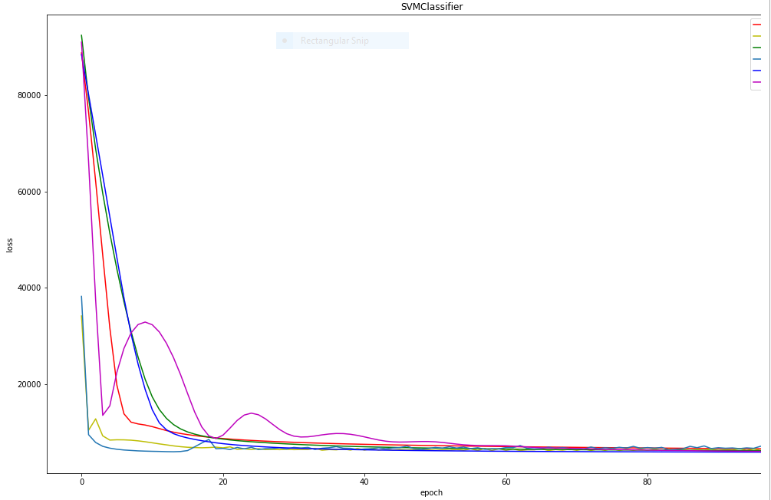

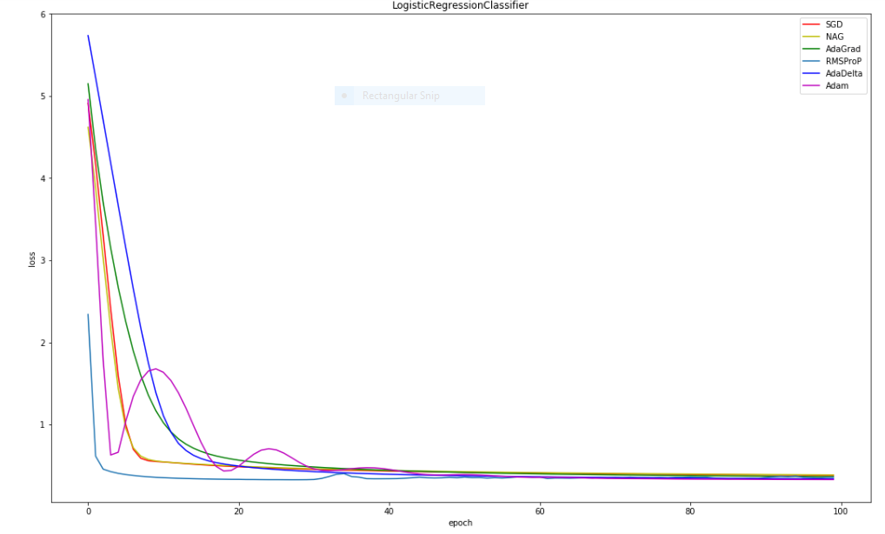

1. **Results analysis:**

For second experiment the estimated updated methods have different curves at different , which indicates its SVM gradient descent and at different values:

max_epoch = 100

batch_size = 11000

**13. Similarities and differences between logistic regression and linear classification:**

The logistic regression is called as a linear classifier because it produces a decision boundary which is linear in nature. So, the classification makes by logistic regression is linear classification only.

**Regression:** given a set of data, find the best relationship that represents the set of data.

**Classification:** given a known relationship, identify the class that the data belongs to.

We can see that regression and classification start from opposing ends: to find a pattern or to find the pattern that it belongs to.

**14. Summary:**

Logistic regression measures the relationship between the categorical dependent variable and one or more independent variables by estimating probabilities using a logistic function, which is the cumulative logistic distribution. Thus, it treats the same set of problems as prohibit regression using similar techniques, with the latter using a cumulative normal distribution curve instead.

A linear classifier achieves this by making a classification decision based on the value of a linear combination of the characteristics. An object's characteristics are also known as feature values and are typically presented to the machine in a vector called a feature vector.

**Classification Problems,** **Classification** is a central topic in machine learning that has to do with teaching machines how to group together data by criteria. Classification is the process where computers group data together based on predetermined characteristics — this is called supervised learning.

**Classification problems** try to determine group membership by deriving probabilities. The first technique ever used was linear discriminant analysis (LDA), proposed by Sir R.A. Fisher in 1936—he used to classify irises. I do not understand it fully, but believe that it used linear regression to derive probabilities for each group, and then used a Mahalanobis distance measure to assign to the closest group.

**Stochastic gradient descent** (often shortened to **SGD**), also known as **incremental** gradient descent, is a stochastic approximation of the gradient descent optimization and iterative method for minimizing an objective function that is written as a sum of differentiable functions. In other words, SGD tries to find minima or maxima by iteration. Stochastic gradient descent is a popular algorithm for training a wide range of models in machine learning, including (linear) support vector machines, logistic regression and graphical models.When combined with the backpropagation algorithm, it is the *de facto* standard algorithm for training artificial neural networks.